- Solve the cryptarithmetic problem in Figure 6.2 by hand, using the strategy of backtracking with forward checking and the MRV and least-constraining-value heuristics.
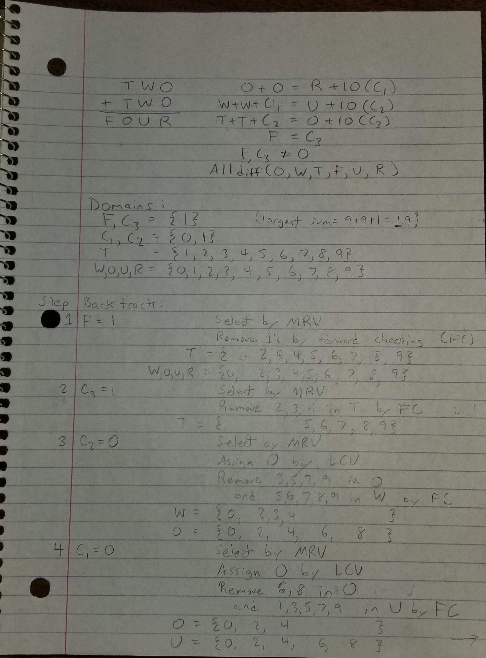
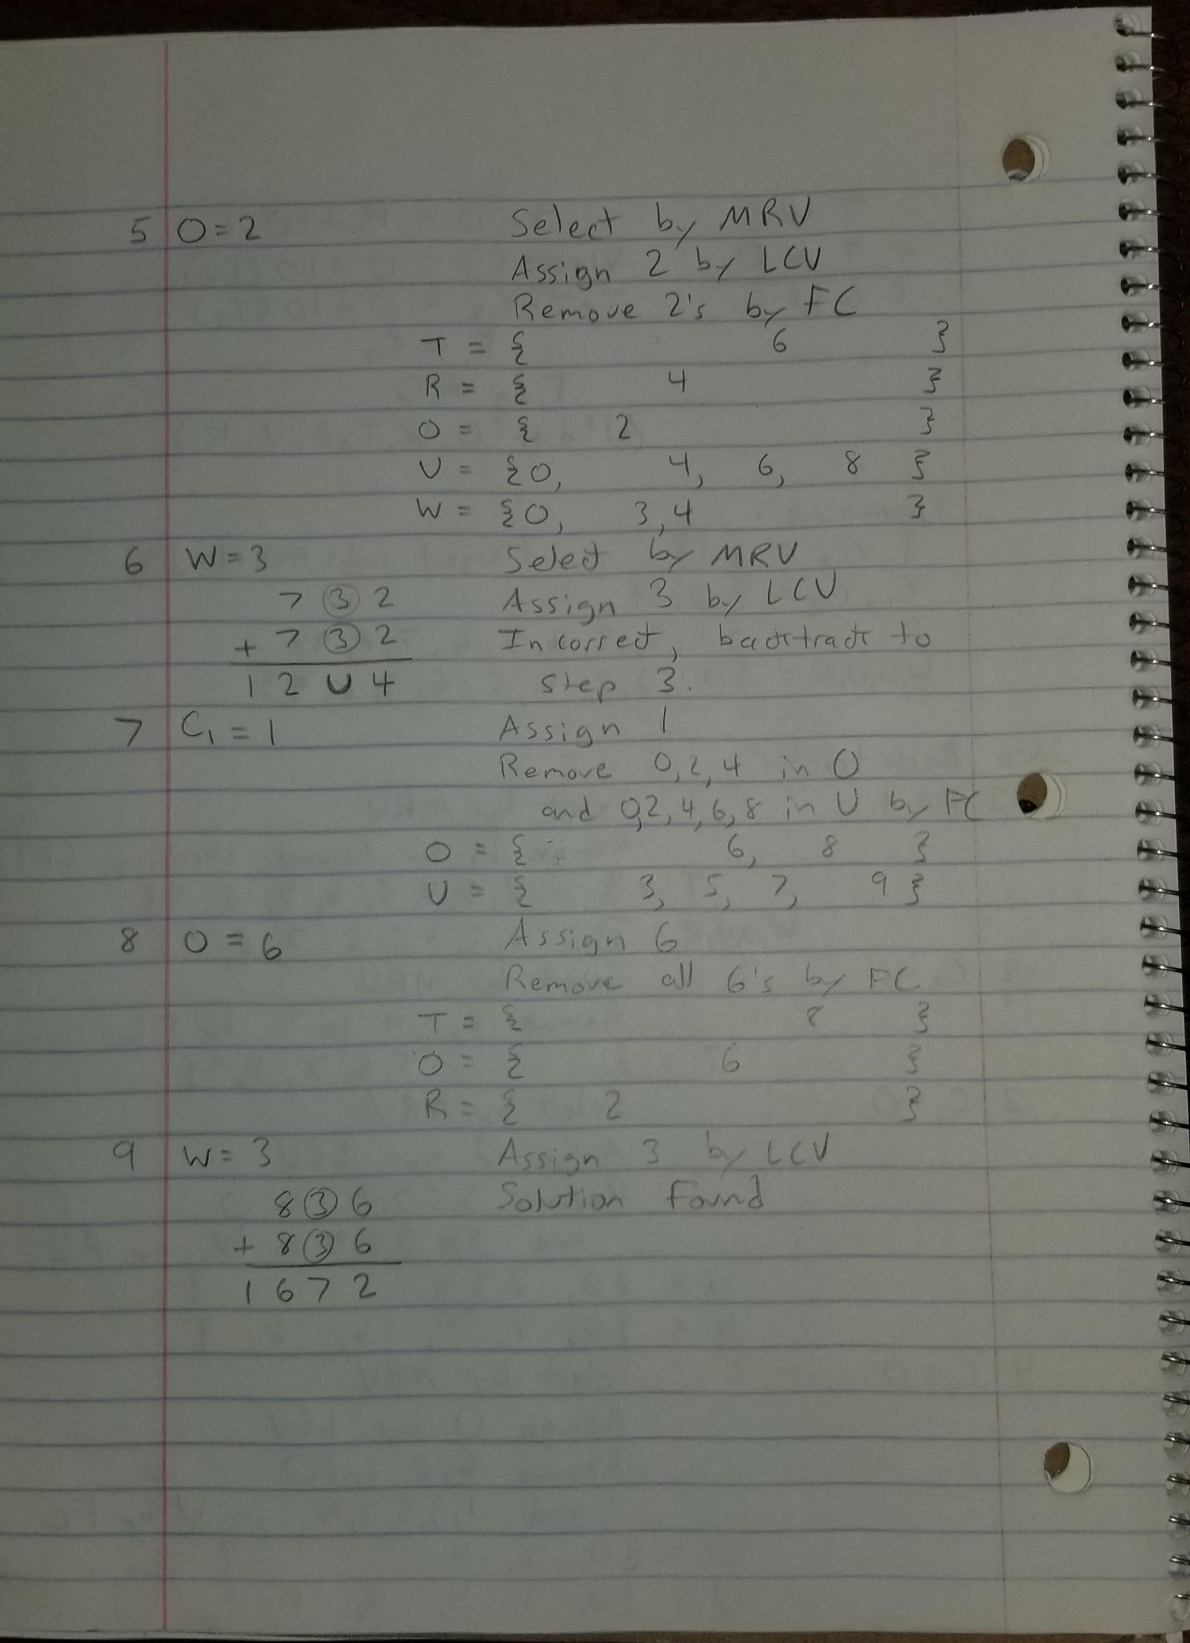
- Show how a single ternary constraint such as A + B = C can be turned into three binary constraints by using an auxiliary variable. You may assume finite domains. (Hint: Consider a new variable that takes on values that are pairs of other values, and consider constraints such as X is the first element of the pair Y). Show how constraints with more than three variables can be treated similarly.
Let there be an auxiliary variable which has a domain containing all valid 3-tuples which would satisfy the aforementioned constraint. The constraint is only satisfied if the tuple within the domain of is consistent with a value contained in the domain of , thus . We can then define two more constraints, and following the same rules.
Following the methodology from above, one can observe that a larger constraint containing variables can then be reduced to a set of constraints between an auxiliary variable and the original variables.
- Answer the following questions regarding local search.

Correct, since False is never true, RHS is never compared to LHS.

Incorrect, since False is not valid in all models of True.

Correct, since LHS is true when A and B are true

Incorrect, because when A is true and B is true, LHS is true, but RHS is not.

Correct, because when B is true but A is false, RHS becomes true but LHS is false.

Incorrect, since if only B is true, then LHS is true, but RHS is false.

Correct, the truth values of these are equivalent for all values of A, B, and C.

Correct, if all values are false, then both LHS and RHS are always false.

Incorrect, when only B and D are true, LHS is true, but RHS is false.

Correct, satisfied when A is true and B is false.

Correct, satisfied when both A and B are false, or when both A and B are true. This can be simplified as biconditional.

Incorrect, because will have 4 models, whereas will have 8, in any arrangement of A, B, and C.
- According to some, a person who likes cats (C), likes dogs (D) if he/she likes all animals (A), but otherwise does not. Which of the following are correct representations of this assertion?

Incorrect, because you don’t have to like cats and dogs in order to like all animals (we’re interpreting in a shallow manner, according to Piazza post #76).

Correct, because if one likes cats, then they like dogs if and only if they like all animals.

Incorrect, because this statement is true no matter what.
- This question considers representing satisfiability (SAT) problems as CSPs.
  - Draw the constraint graph corresponding to the SAT problem

X1
X2
X3
X4
X5

  - How many solutions are there for this general SAT problem as a function of n?
This problem has 6 satisfying solutions. One for all values of X being false, and one solution for each X. So in the case of variables, there would be solutions.
  - Suppose we apply BACKTRACKING-SEARCH (page 215) to find all solutions to a SAT CSP of the type given in (a). (To find all solutions to a CSP, we simply modify the basic algorithm so it continues searching after each solution is found.) Assume that variables are ordered X1 , ..., Xn and false is ordered before true. How much time will the algorithm take to terminate? (Write an O() expression as a function of n.)
The Backtracking-Search algorithm is a form of recursive Depth First Search (DFS). This SAT problem generates a search tree containing leaves. Normally in a backtracking search algorithm, a single solution is found, but in this one, all solutions must be found, thus the DFS will examine every leaf of the tree. Therefore, this algorithm runs in the same time as worst-case DFS, thus the runtime should be .

